MINOR PROJECT

STUDENT PROGRESS TRACKER SYSTEM

Project Overview
This project helps you practice all fundamental Python concepts covered in class:
● Variables Data Types
● Taking User Input
● Arithmetic Operators
● Conditions (if, elif, else)
● For Loop
● While Loop
● Do‑While Logic in Python
● Output Formatting with f‑strings

You will create a simple system that collects a student’s marks, calculates results, and generates a progress report.

2. Project Requirements
Your program must include all the parts below.

PART 1: Welcome Screen
When the program starts, display:
-----------------------------------------
STUDENT PROGRESS TRACKER SYSTEM
-----------------------------------------

Ask the user to enter:
● Student Name
● Class
● Roll Number
Store these values using Python variables.

PART 2: Enter Subject Marks
1. Ask the user how many subjects they want to enter.
2. Use a for loop to get marks for each subject.
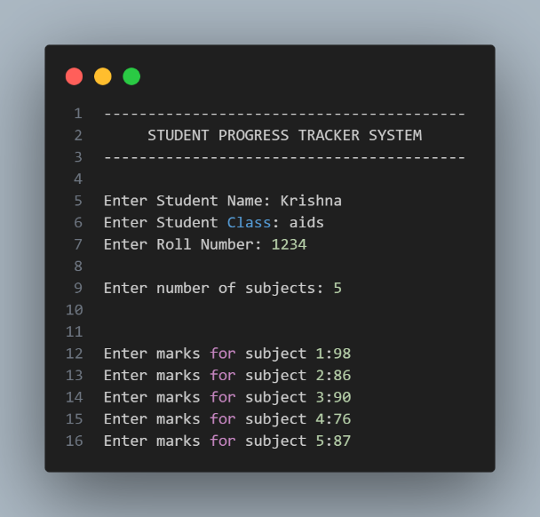
3. Calculate:
● Total Marks
● Average Marks

PART 3: Grade Calculation
Using if / elif / else, assign a grade based on average:
Average Marks Grade
90 and above A
75–89 B
50–74 C
35–49 D
Below 35 Fail

PART 4: Pass / Fail Logic
The student fails if any subject has marks below 35.
Otherwise, they pass.
Use conditions to check this.

PART 5: Display Progress Report
Print the following formatted report:
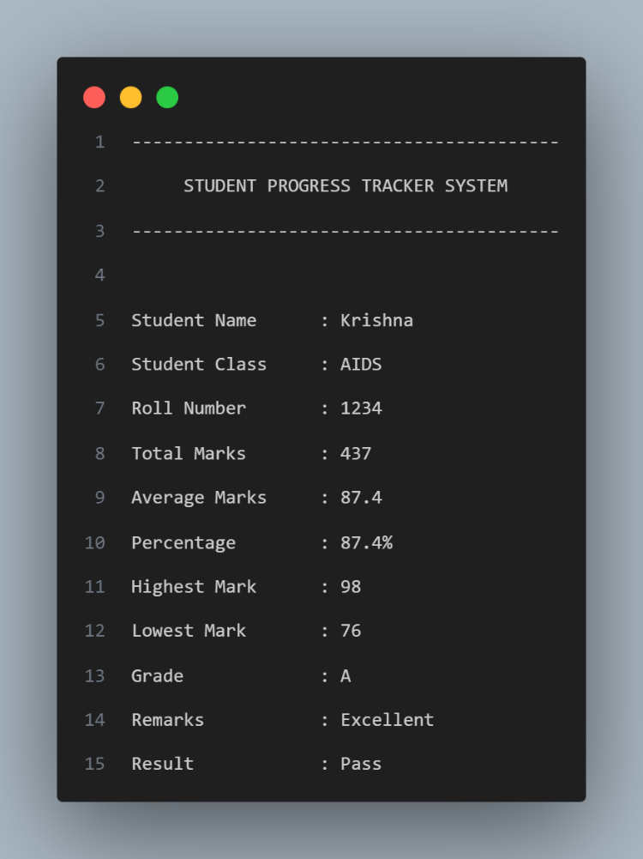

PART 6: Menu System
After the report, show this menu:
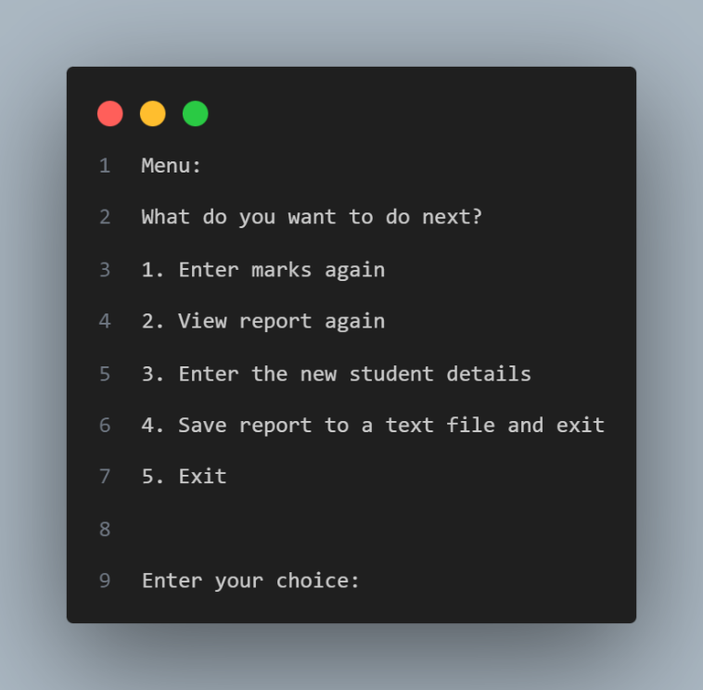
Requirements:
● Use a while True loop
● End the loop only when the user selects 3. Exit
This simulates do‑while behaviour.

3. Optional Features
Students may add:
● Highest and Lowest Marks
● Percentage
● Remarks (Excellent / Good / Needs Improvement)
● Save report to a text file
● Option to run the whole system again

Conclusion:
This Minor Project – Student Progress Report is a consoled base application. It is Designed with using a fundamental concept learned in course. They are Variables, Athematic Operations, loops like while loop, for loops, Conditional statements, input, output, f-Strings (formatted output)
The system allows the user to enter subject marks to calculate the average, total marks, grade, percentage, minimum marks, maximum marks, by using this we can add remarks, Logic pass/fail.
Here, in this project there is a menu option that is crated by using loops so until user enter exit option the loop will continue. The loop’s written logic is enhancing our logical thinking to improve technical skills to grow higher in this field.
Overall, this project helps beginners to understand different fundamental concepts in python to know about real word applications.

Future Scope:
This Student Progress report is consoled base application. We can convert this in to a useful website for educational intuitions to create student progress report by using marks easily and calculate the average, total marks, grade, percentage, minimum marks, maximum marks, by using this we can add remarks, Logic pass/fail. For make it as future one project develop this project with SQL, Django, HTML, CSS and more to work this as real life application.

